Remove the emoji on the terms and agreement. 
Enrollment form u most have some trap of the each input only word not number and be specific of the enrollment form. If the input says only name u just need to put some word only nonumber.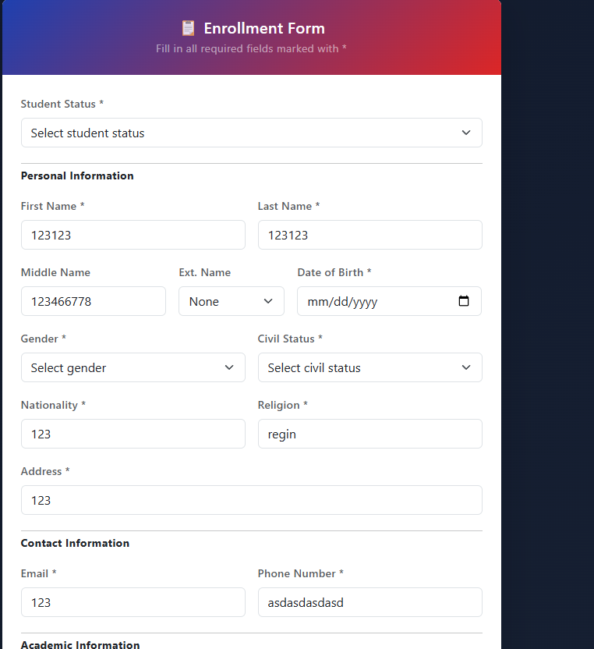
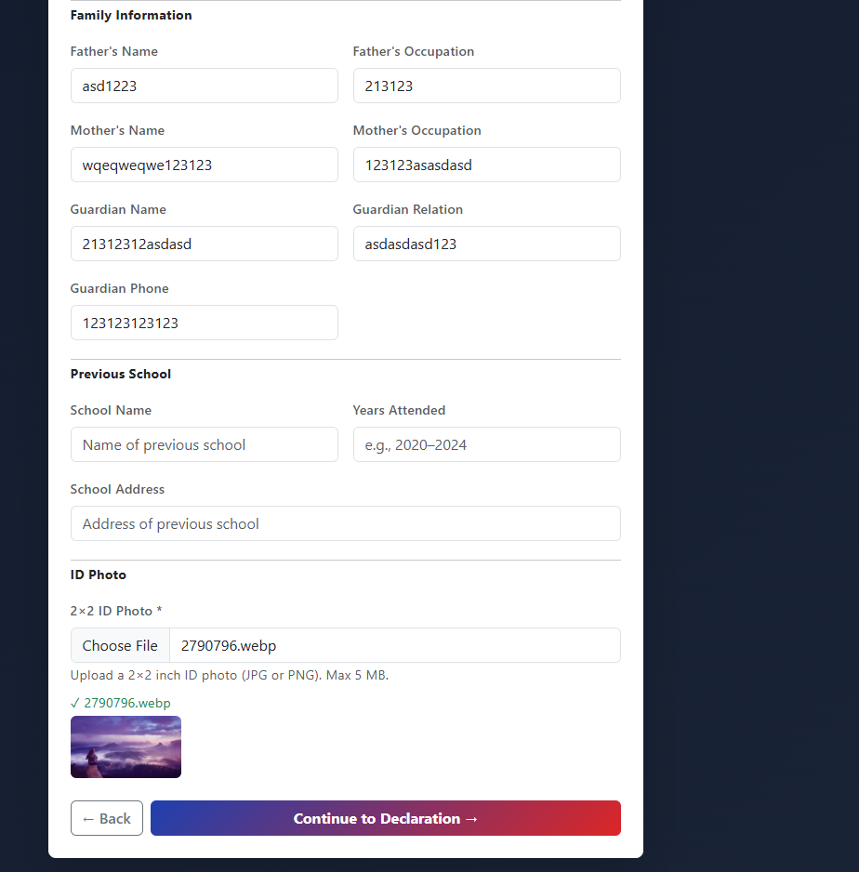

Remove the other only male and female
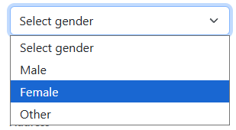
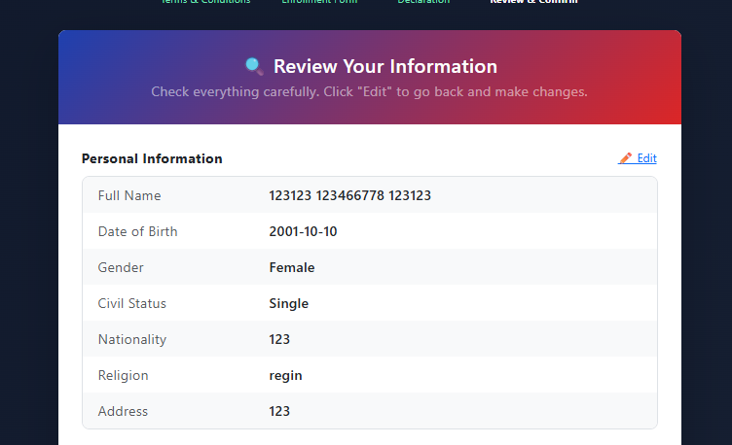
Kay langan if mo edit kug information nako kay langan dili na siya mo balik sa enrollment form adto ra sa review and confirm.
Can you get the profile only the notification is already double on this side only logout is remain